Filename: SRVacMPI_2_1_7.mph

Created In: COMSOL Multiphysics 5.3a (Build:201)

Modules Used:

* COMSOL Multiphysics
* CAD Import Module
* Structural Mechanics Module
* Ray Optics Module

Application Access: Run in browser

Experience:

1. Received an error upon opening. The error is shown below in Figure 1:

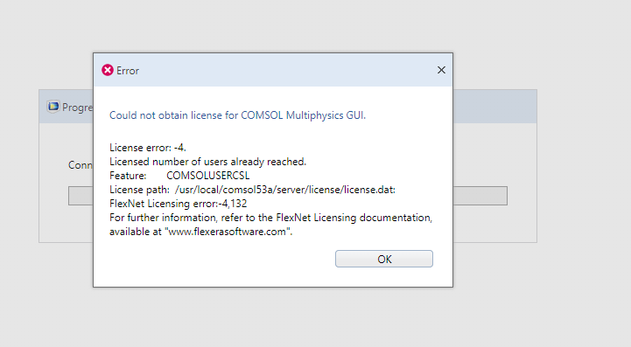

Filename: BeamLineMirrorAnalyzer0103.mph

Created In: COMSOL Multiphysics 5.3a (Build:201)

Modules Used:

* COMSOL Multiphysics
* CAD Import Module
* Structural Mechanics Module

Application Access: Run in browser

Experience:

* Received the same error upon opening.

General Website Notes:

* I noticed that the application does not close out when you close the browser window. For example, when I opened the beamline mirror analyzer application and received the license error I close the browser tab that had opened when I activated the application. I noticed then that the application library showed the app still open and active. I could see how someone may exit the website and accidently leave an app running which would use up a license.